Project 2
Zaid Alssaraj

Server: 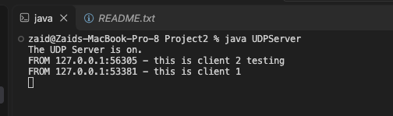
Clients:


